**Applied Thermodynamics for Engineers**

**Dipankar N. Basu**

**Department of Mechanical Engineering**

**Indian Institute of Technology - Guwahati**

**Lecture – 02**

**Review of Thermodynamic Principles**

Hello friends, so again we meet in this particular week, where we have started our course on applied thermodynamics for engineers. During this week, we are reviewing the basic principles of thermodynamics, or whatever you must have learned in your basic thermodynamics course. We are reviewing those topics and preparing ourselves to go into the deeper discussions on the topic of applied thermodynamics.

In the previous lecture, which is the first lecture of this course, we have just reintroduced or tried to revise the concept of thermodynamic system, state and properties. Different types of thermodynamics systems basically, the closed and open systems were discussed. Then about different ways of defining properties, whereby we can classify a property as intensive or extensive.

Then we discussed, the concept of thermodynamics state, equilibrium state and finally, the zeroth law of thermodynamics which give away the concept of the property called temperature. So, today we are going to take the discussion forward and looking to discuss about the first and second laws of thermodynamics.

**(Refer Slide Time: 01:45)**

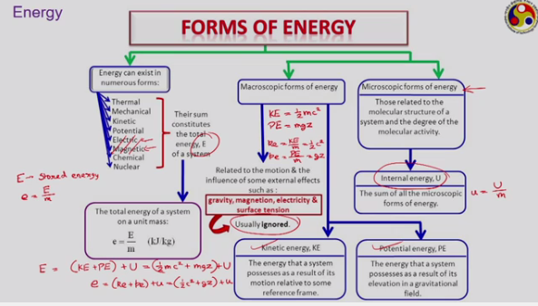

The first term that we have here for discussion today is the energy. Energy is a very important in any discussion of thermodynamics. Thermodynamics is often defined as a science of energy.

From a layman’s point of view or any general discussion point of view, the energy content in a system can be classified into different categories as shown here. We can assume that energy can exist in a system in numerous forms like thermal energy, mechanical energy, kinetic, potential, electrical energy, magnetic energy, chemical or nuclear energy under certain situations. So, it is possible that a system can have all these kinds of energies and the sum of all these types of energies is called the total energy content of the system. We are going to use ‘E’ to denote the total energy content of the system. We also called it as stored energy so, this symbol ‘E’ is used to denote the stored energy. It is an extensive property that is why we are using the symbol ‘E’ and its specific version that is ‘e’ defined as

or stored energy per unit mass is an internal or intensive property.

